**Name: Nurul kawsar**

**ID : 24070144**

**2. Sum of Two Numbers**

**Problem:**

**Write a Java program to take two numbers as input and print their sum.**

**Java file :**

import java.util.Scanner;

public class SumTwoNumbers {

public static void main(String[] args) {

Scanner scanner = new Scanner(System.in);

System.out.print("Enter first number: ");

int num1 = scanner.nextInt();

System.out.print("Enter second number: ");

int num2 = scanner.nextInt();

int sum = num1 + num2;

System.out.println("Sum: " + sum);

scanner.close();

}

}

**Explanation :**

• This program takes two integer inputs from the user.

• It uses the Scanner class to get user input.

• The numbers are stored in num1 and num2, and their sum is calculated using num1 + num2.

• The sum is displayed using System.out.println().

• Finally, scanner.close() is used to close the scanner to prevent resource leaks.

Output:

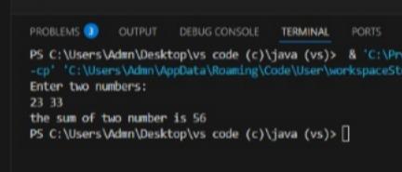

**3. Check if a Number is Even or Odd**

**Problem:**

**Write a Java program that checks whether a number is even or odd.**

**Java file :**

import java.util.Scanner;

public class EvenOddCheck {

public static void main(String[] args) {

Scanner scanner = new Scanner(System.in);

System.out.print("Enter a number: ");

int num = scanner.nextInt();

if (num % 2 == 0) {

System.out.println(num + " is even.");

} else {

System.out.println(num + " is odd.");

}

scanner.close();

}

}

**Explanation :**

* The program asks the user to enter a number.
* It checks if the number is divisible by 2 using num % 2 == 0:
  + If true, the number is even.
  + Otherwise, it is odd.
* The result is printed accordingly.

Output:

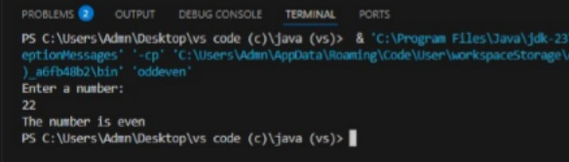

**4. Find the Factorial of a Number**

**Problem:**

**Write a Java program to calculate the factorial of a number.**

**Java file :**

import java.util.Scanner;

public class Factorial {

public static void main(String[] args) {

Scanner scanner = new Scanner(System.in);

System.out.print("Enter a number: ");

int num = scanner.nextInt();

long factorial = 1;

for (int i = 1; i <= num; i++) {

factorial *= i;

}

System.out.println("Factorial of " + num + " is: " + factorial);

scanner.close();

}

}

**Explanation :**

• The program asks the user to input a number.

• It initializes a variable factorial = 1.

• A for loop runs from 1 to num, multiplying each value to factorial.

• The final result is printed after the loop.

Output:

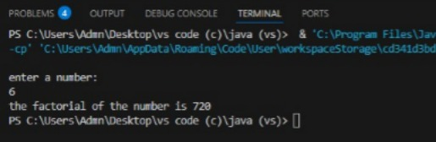

**5. Check if a Number is Prime**

**Problem:**

**Write a Java program to check if a number is prime.**

**Java file :**

import java.util.Scanner;

public class PrimeCheck {

public static void main(String[] args) {

Scanner scanner = new Scanner(System.in);

System.out.print("Enter a number: ");

int num = scanner.nextInt();

boolean isPrime = num > 1;

for (int i = 2; i <= Math.sqrt(num); i++) {

if (num % i == 0) {

isPrime = false;

break;

}

}

if (isPrime) {

System.out.println(num + " is a prime number.");

} else {

System.out.println(num + " is not a prime number.");

}

scanner.close();

}

}

**Explanation :**

• A prime number is a number greater than 1 that has only two factors: **1 and itself**.

• The program checks if num is greater than 1.

• It then iterates from 2 to sqrt(num):

* If num is divisible by any number in this range, it is **not a prime**.
* The break statement stops the loop early if a divisor is found.

• If no divisors are found, the number is **prime**.

Output:

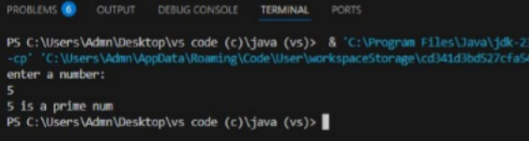

**6. Reverse a String**

**Problem:**

**Write a Java program to reverse a string.**

**Java file :**

import java.util.Scanner;

public class ReverseString {

public static void main(String[] args) {

Scanner scanner = new Scanner(System.in);

System.out.print("Enter a string: ");

String input = scanner.nextLine();

String reversed = new StringBuilder(input).reverse().toString();

System.out.println("Reversed string: " + reversed);

scanner.close();

}

}

**Explanation :**

* The program takes a **string** input from the user.
* It uses the StringBuilder class, which has a built-in reverse() method.
* The reversed string is printed.

**Output:**

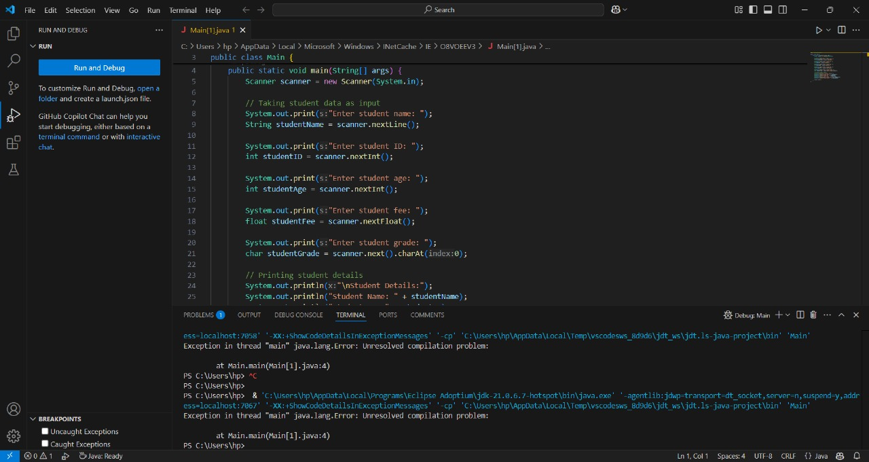

**8. Find the Largest Among Three Numbers**

**Problem:**

**Write a Java program to find the largest among three numbers.**

**Java file :**

import java.util.Scanner;

public class LargestOfThree {

public static void main(String[] args) {

Scanner scanner = new Scanner(System.in);

// Taking input from the user

System.out.print("Enter first number: ");

int num1 = scanner.nextInt();

System.out.print("Enter second number: ");

int num2 = scanner.nextInt();

System.out.print("Enter third number: ");

int num3 = scanner.nextInt();

// Finding the largest number

int largest;

if (num1 >= num2 && num1 >= num3) {

largest = num1;

} else if (num2 >= num1 && num2 >= num3) {

largest = num2;

} else {

largest = num3;

}

// Printing the largest number

System.out.println("The largest number is: " + largest);

scanner.close();

}

}

**Explanation :**

• **Takes three numbers as input** using Scanner.

• **Compares the numbers** using if-else to determine the largest.

• **Prints the largest number**.

• **Alternative approach:** Use Math.max():

Output;

